LAB221 Assignment | Type: | Short Assignment
 | Code: | J2.S.P0011
 | LOC: | 64
 | Slot(s): | 2

Title
Simple calculator
Background Context
We often use a simple calculator in window family that is available in every window family. With java swing, you can also easily make your calculator, just for some basics calculation.
Program Specifications
Create an application using java swing to create a simple calculator.
You can implement your application by making some classes:
1. CalculatorLogic.java
This class contains method for calculation like +, -, *, / or event for conversion.
2. MyCaculator.java
Make a GUI for simple calculator and do the calculation.
Function details:
- Display the GUI like figure (1).
- When users click on a button, do the corresponding task.

Expectation of User interface:

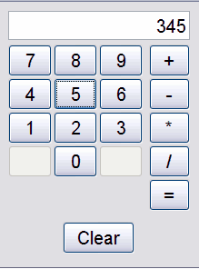 (1)
Guidelines

